NAME:B.ANJALI
REGISTER NUMBER:192371062
COURSE:PROGRAMMING IN JAVA
COURSE CODE:CSA0903
DATE :07-08-2026

Generate a code and execute for the following
1. Multiple catch statements
2. StringIndexOfBoundsException
3. finally
4. throw (to check person is eligible to poll the vote)
5. Throw
1.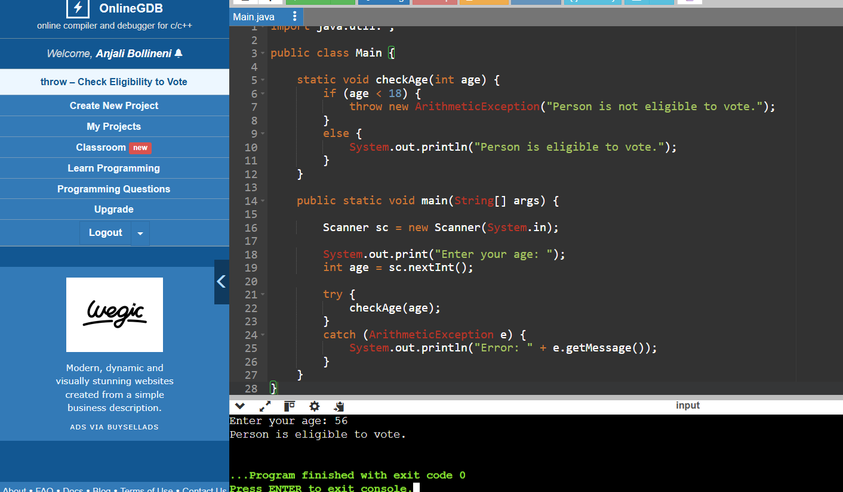
2.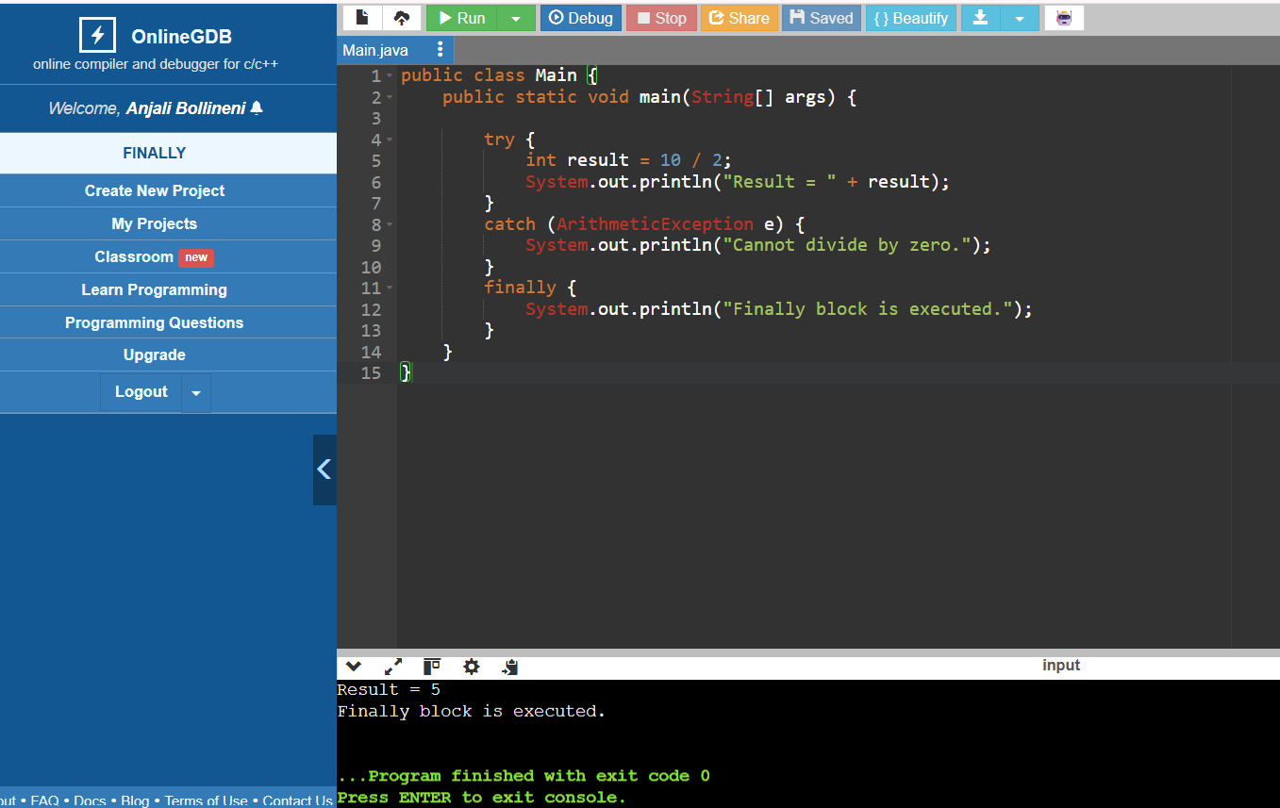
3.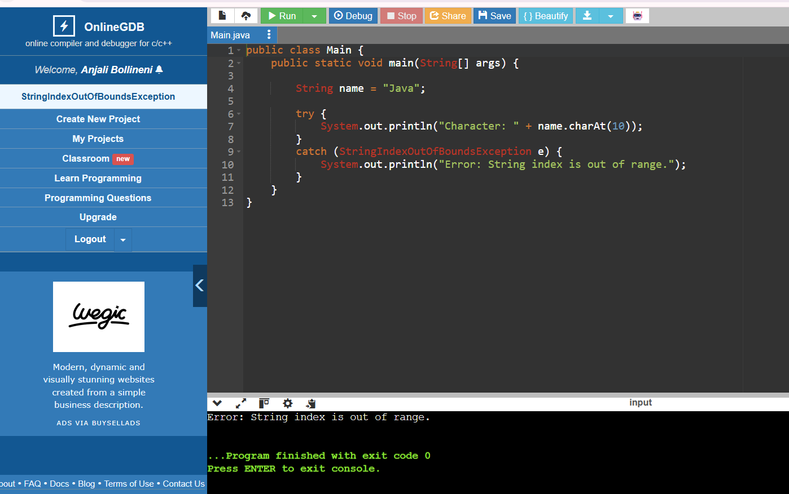
4.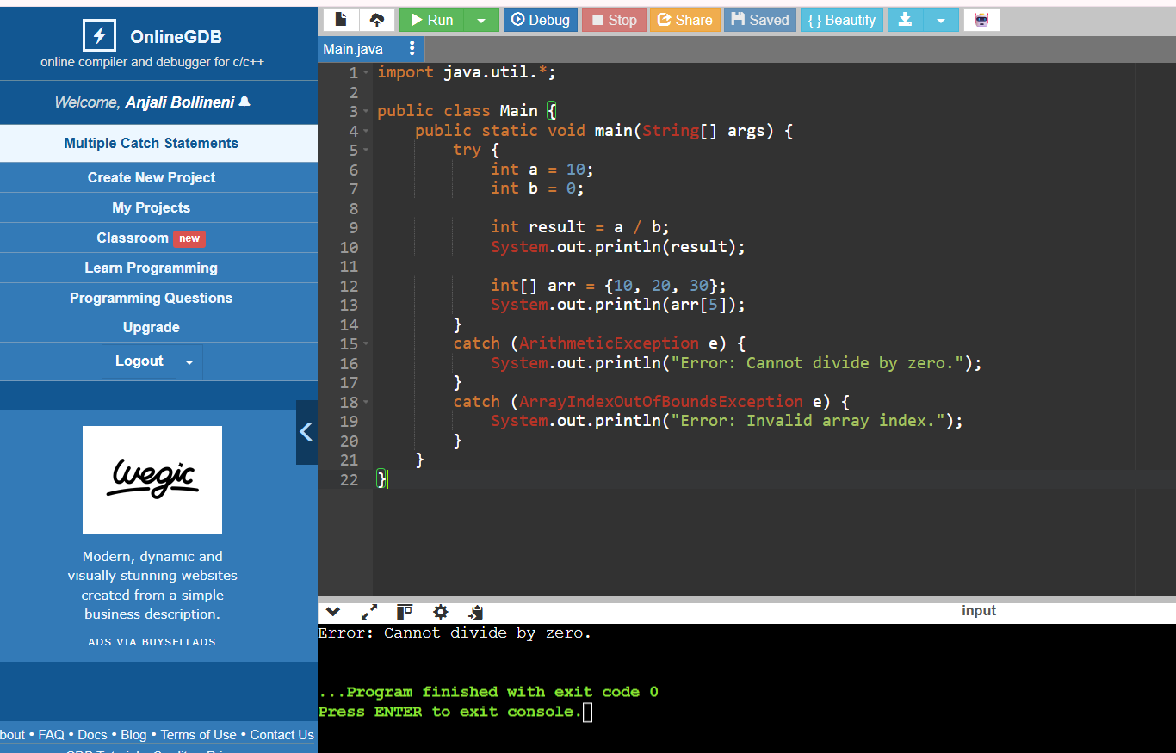

5.